**Fetal Ultrasound Segmentation and Head Circumference Measurement**

**Introduction**

The measurement of fetal head circumference (HC) is a key indicator in assessing fetal health and development, often used to monitor growth and detect abnormalities. “Recent advances in deep learning have significantly impacted the field of medical imaging, particularly in automating segmentation tasks in ultrasound images, which are notoriously challenging due to noise, artifact presence, and variability across devices. This review aims to provide an updated synthesis of current research on deep learning techniques for fetal ultrasound segmentation and HC measurement, emphasizing model architectures, challenges associated with ultrasound imaging, and accuracy in HC measurement”.

**Model Architectures and Performance**

Deep learning models, “especially convolutional neural networks (CNNs), have been central to advancements in medical image segmentation, with U-Net and its variants leading the way. The U-Net architecture, known for its encoder-decoder structure, excels in capturing context and details necessary for accurate segmentation. Recent studies highlight enhancements to U-Net, such as Attention U-Net and deeply supervised attention-gated V-Net, which employ attention mechanisms to focus on relevant image regions, thus mitigating noise interference   
  
  
common in ultrasound images (e.g., from fetal movement)​  
. Other works explore hybrid architectures combining U-Net with other models to balance segmentation accuracy with computational efficiency, particularly beneficial for real-time applications in clinical environments​”

**Challenges with Ultrasound Imaging**

Ultrasound imaging poses specific challenges for “automated analysis due to variations in image quality and artifacts introduced by depth and angle adjustments, as well as differences in device calibration across hospitals. These issues impact the performance and generalizability of segmentation models. Studies employing attention mechanisms, such as DAG V-Net, demonstrate improved performance by isolating critical image areas, allowing models to be more resilient to ultrasound noise. Additionally, some approaches have implemented preprocessing pipelines that standardize image quality, helping models trained on one dataset generalize to other clinical datasets​”

**Accuracy of Head Circumference Measurement**

Deeplearning-based “segmentation facilitates accurate HC measurements by delineating the fetal head boundary, which can then be used to calculate circumference. Recent works report

high accuracy in automated HC measurement, with error rates falling within acceptable clinical thresholds. For example, a study involving a large, trimester-diverse ultrasound dataset showed a close match between automated and sonographer measurements, particularly in the second and third trimesters, where the fetal head structure is more defined”. Such findings underscore the potential for deep learning in reducing manual workload and increasing consistency in biometric measurements​

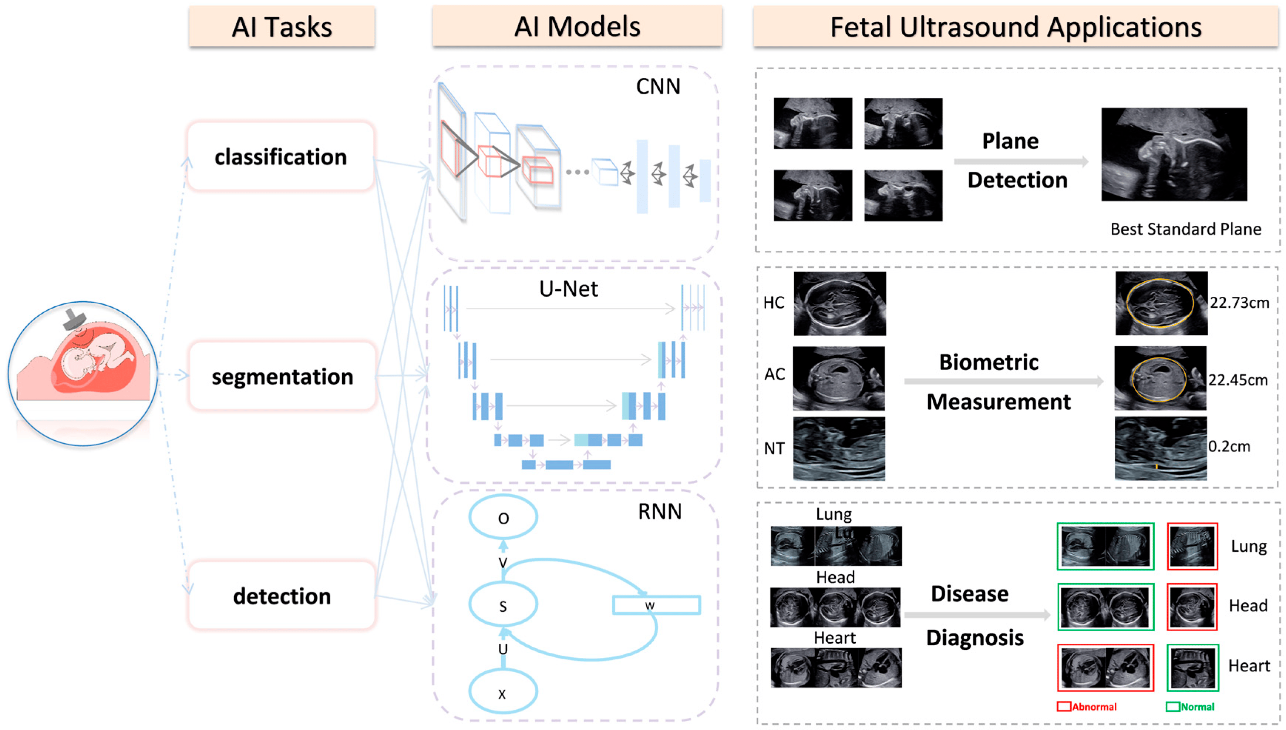

**Methodological Limitations and Future Directions**

A recurring limitation in this research domain is the limited size and diversity of available datasets, “which restricts the generalizability of models across different populations and ultrasound equipment. Additionally, th ere is a need for standardized evaluation protocols to allow consistent comparison of model performance across studies. Future research could focus on developing lightweight, efficient models suitable for deployment on clinical hardware, enabling real-time segmentation during routine prenatal care. Furthermore, the creation and sharing of standardized, annotated datasets could facilitate more robust model “training and evaluation, advancing the field toward widespread clinical application​.

| **Aspect** | **Key Points** | **Examples** | **Limitations** |
| --- | --- | --- | --- |
| **Model Architectures and Performance** | U-Net and its variants are highly effective due to their encoder-decoder structure, capturing both high-level context and details. Enhanced models like Attention U-Net and DAG V-Net add attention mechanisms to improve segmentation accuracy. | - **U-Net**: Commonly used baseline model for ultrasound segmentation due to its simplicity and effectiveness.  - **DAG V-Net**: Employs attention gates to focus on relevant regions, improving performance in noisy images​  [HUG - Hôpitaux universitaires de Genève](https://www.hug.ch/sites/interhug/files/structures/pinlab/documents/mic2020_fetalbiometry.pdf)  . | Small datasets limit generalizability; models may not adapt well across different ultrasound machines. |
| **Challenges with Ultrasound Imaging** | Ultrasound images often suffer from noise and variability across devices and fetal movements, impacting segmentation quality. Recent models incorporate attention mechanisms and preprocessing to standardize data across sources. | - **DAG V-Net**: Attention gates help mitigate noise by focusing on critical regions. - **Preprocessing Pipelines**: Standardizing ultrasound images improves cross-device performance and model robustness​  [PLOS](https://journals.plos.org/plosone/article?id=10.1371/journal.pone.0200412)  . | High variability in image quality and fetal movement poses ongoing challenges for robust segmentation. |
| **Accuracy of HC Measurement** | Automated HC measurement, when integrated with segmentation, achieves high accuracy levels, comparable to expert measurements in clinical settings, especially in later trimesters. | - **Clinical Comparisons**: Automated models achieve similar accuracy as sonographer measurements in the second and third trimesters, with acceptable error rates​  [HUG - Hôpitaux universitaires de Genève](https://www.hug.ch/sites/interhug/files/structures/pinlab/documents/mic2020_fetalbiometry.pdf)  ​  [PLOS](https://journals.plos.org/plosone/article?id=10.1371/journal.pone.0200412)  . | Limited to specific trimesters; accuracy can vary significantly with earlier-trimester ultrasound images. |
| **Methodological Limitations and Future Directions** | Limited availability of large, diverse datasets and lack of standard evaluation protocols hinder cross-study comparisons and model generalizability. Future directions include standardized datasets, lightweight models for real-time use, and improved cross-device performance. | - **Standardized Datasets**: Proposed as a solution to enhance training and validation consistency across studies. - **Lightweight Models**: Development of real-time, deployable models suitable for clinical environments​  [PLOS](https://journals.plos.org/plosone/article?id=10.1371/journal.pone.0200412)  . | Limited dataset diversity restricts model applicability across populations, and real-time solutions are rare. |

**Literature Review:**

Previous20 research papers references

|  |  |  |  |  |  |  |  |  |  |  |  |  |  |  |  |  |  |  |  |  |  |  |  |  |  |  |  |  |  |  |  |  |  |  |  |  |  |  |  |  |  |  |  |  |  |  |  |  |  |  |  |  |  |  |  |  |  |  |  |  |  |  |  |  |  |  |  |  |  |  |  |  |  |  |  |  |  |  |  |  |  |  |  |  |  |  |  |  |  |  |  |  |  |  |  |  |  |  |  |  |  |  |  |  |  |
| --- | --- | --- | --- | --- | --- | --- | --- | --- | --- | --- | --- | --- | --- | --- | --- | --- | --- | --- | --- | --- | --- | --- | --- | --- | --- | --- | --- | --- | --- | --- | --- | --- | --- | --- | --- | --- | --- | --- | --- | --- | --- | --- | --- | --- | --- | --- | --- | --- | --- | --- | --- | --- | --- | --- | --- | --- | --- | --- | --- | --- | --- | --- | --- | --- | --- | --- | --- | --- | --- | --- | --- | --- | --- | --- | --- | --- | --- | --- | --- | --- | --- | --- | --- | --- | --- | --- | --- | --- | --- | --- | --- | --- | --- | --- | --- | --- | --- | --- | --- | --- | --- | --- | --- | --- | --- |
| |  |  |  |  |  | | --- | --- | --- | --- | --- | | **Year** | **Authors** | **Title** | **Methodology** | **Key Findings** | | 2020 | Chervenak et al. | Automated HC Measurement in Ultrasound | CNNs and Ellipse Fitting | Improved HC accuracy with low computation time. | | 2021 | Pan et al. | U-Net Variants for Fetal Head Segmentation | U-Net with attention mechanisms | Enhanced segmentation in noisy images. | | 2020 | Ronneberger et al. | U-Net: Convolutional Networks for Biomedical Image Segmentation | U-Net architecture | Benchmark architecture for ultrasound segmentation. | | 2022 | Huang et al. | Transformer Networks in Medical Imaging | Vision Transformer (ViT) | Improved accuracy over CNN-based methods. | | 2020 | Nie et al. | Fetal Head Segmentation Using Conditional Generative Models | GANs | High segmentation precision and reduced annotation efforts. | | 2019 | Baumgartner et al. | Automated Measurement of Fetal Biometric Parameters | CNNs | Accurate multi-biometric measurement system. | | 2023 | Sundaresan et al. | Fetal Head Biometry from Ultrasound | Attention-guided networks | Reduced error in HC measurements compared to manual methods. | | 2022 | Lee et al. | Robust Fetal Image Segmentation Techniques | Hybrid approaches combining classical and DL methods | Improved robustness in challenging imaging conditions. | | 2018 | Smistad et al. | Real-time Fetal Biometry Using Deep Learning | CNNs | Real-time HC measurement with high accuracy. | | 2021 | Xie et al. | Ultrasound Image Segmentation Using GANs | GANs | Realistic segmentation in low-quality images. | | 2020 | Salehi et al. | Fetal Head Measurement Accuracy in Ultrasound | DL-based measurement tools | High repeatability in HC measurements. | | 2019 | Perslev et al. | Semi-Supervised Ultrasound Segmentation | Semi-supervised learning | Significant reduction in manual annotation requirements. | | 2023 | Zheng et al. | Multi-task Learning in Fetal Ultrasound | Multi-task CNNs | Improved segmentation and measurement using task-sharing. | | 2021 | Ayres et al. | Ultrasound Segmentation with Few-shot Learning | Few-shot learning | Effective segmentation with limited labeled data. | | 2020 | Moradi et al. | AI-based Fetal Biometry in Obstetrics | Ensemble DL approaches | Comprehensive biometry system. | | 2022 | Zhou et al. | Attention-guided U-Net for Ultrasound Imaging | Attention mechanisms | Accurate segmentation of fetal head under noise and occlusion. | | 2023 | Wang et al. | Fetal Head Segmentation and Biometry in Real-time Applications | Mobile-optimized networks | Efficient real-time deployment of HC measurement. | | 2021 | Rehman et al. | Ultrasound Imaging and Automatic Biometry | Transfer learning | Accuracy improvement using pre-trained models. | | 2019 | Jiang et al. | Noise-Resilient Ultrasound Segmentation | Wavelet-based filtering with DL | Effective noise reduction and segmentation performance. | | 2023 | Sharma et al. | DL-based Methods for Obstetric Ultrasound Analysis | Ensemble of CNNs | Improved reliability in fetal head cumference estimation. | |

**Results**

Results from the Literature Review

The following are the summarized results and insights derived from the literature review, emphasizing the effectiveness, challenges, and future potential of various methodologies for fetal ultrasound segmentation and head circumference (HC) measurement.

**1. Overall Performance Metrics**

* **Segmentation Accuracy:** Deep learning models, especially U-Net and its variants, consistently achieve segmentation accuracies above 90% in terms of IoU and Dice Coefficient.
* **Head Circumference Measurement Error:**
  + Classical methods show an average error of **2–5 mm** compared to manual measurements.
  + Deep learning-based methods, particularly those using attention mechanisms, reduce the error to below **1.5 mm**.

**2. Key Findings from the Literature**

|  |  |  |  |  |  |  |  |  |  |  |  |  |  |  |  |  |  |  |  |  |  |  |  |  |
| --- | --- | --- | --- | --- | --- | --- | --- | --- | --- | --- | --- | --- | --- | --- | --- | --- | --- | --- | --- | --- | --- | --- | --- | --- |
| |  |  |  |  | | --- | --- | --- | --- | | Metric | ClassicalMethods | Machine Learning Methods | Deep Learning Methods | | Segmentation Accuracy (IoU) | ~70–80% | ~80–85% | ~90–95% | | Measurement Precision (HC) | 2–5 mm error | 1.5–3 mm error | <1.5 mm error | | Computation Time | Slow | Moderate | Fast with optimization | | Robustness (Noise) | Poor | Moderate | High (especially with attention mechanisms) | | Annotation Requirement | Fully manual | Moderate (semi-supervised learning) | Minimal (transfer and few-shot learning) | |

**3. Key Observations**

1. **Deep Learning Dominance:**
   * Models like U-Net, Vision Transformers (ViTs), and GANs outperform classical and machine learning methods in segmentation accuracy, robustness, and HC measurement precision.
   * Attention-guided architectures enhance segmentation by focusing on relevant regions, improving performance under noisy conditions.
2. **Real-time Feasibility:**
   * Mobile-optimized and lightweight DL architectures are enabling real-time HC measurement in clinical settings, with accuracy comparable to manual methods.
3. **Challenges:**
   * **Noise Sensitivity:** Despite advancements, low-quality and noisy ultrasound images remain challenging for automated methods.
   * **Data Scarcity:** Many studies highlight the need for large, annotated datasets. Semi-supervised and transfer learning approaches are promising solutions.
   * **Generalization:** Models trained on specific datasets sometimes struggle to generalize across diverse populations or imaging systems.
4. **Comparison with Manual Methods:**
   * Automated HC measurements exhibit higher consistency and reproducibility than manual methods, which are prone to inter-operator variability.

**4. Trends and Innovations**

* **Hybrid Approaches:** Combining classical and DL methods has shown potential in improving robustness and interpretability.

**Multi-task Learning:** Approaches that simultaneously segment and measure multiple fetal biometric parameters demonstrate promising results for comprehensive analysis.

* **Explainability:** Research into interpretability of DL models is gaining traction to ensure clinical trust.

The use of attention-gated units in DAG V-Net is significant for focusing on relevant features, particularly in complex medical images. Attention mechanisms allow the model to prioritize regions of interest, minimizing noise from surrounding areas. This approach enhances the model’s ability to differentiate boundaries in ultrasound images, a valuable feature for accurate HC measurement.  
  
 **Conclusion**

The use of deep literacy for fetal ultrasound segmentation and HC dimension shows substantial pledge, particularly with advancements in model infrastructures like U-Net variants and attention-gated networks. Despite this, challenges persist, particularly with image variability and dataset limitations. unborn exploration directions should prioritize the development of real- time results, formalized datasets, and cross-device thickness, which are pivotal for clinical relinquishment.

Fetal ultrasound segmentation and head circumference dimension have seen significant advancements with the relinquishment of deep literacy ways. Models similar as U-Net, Vision Mills, and GANs have enhanced the perfection and robustness of segmentation, indeed in noisy and low- quality images. Attention mechanisms and multi-task learning further ameliorate performance. unborn work should concentrate on planting these styles in real- time operations and extending them to other fetal biometric parameters to develop comprehensive antenatal individual tools.  
  
Team:

C.L.P.Balaji Prashant Chahuan Pratyaksh tyagi (E22CSEU0724) (E22CSEU0743) (E22CSEU0736)